Jersey Bat Rescue Form  JBG in partnership with JSPCA and New Era www.jerseybatgroup.org |  |  |  |  | 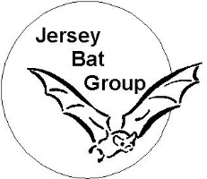
This form has been designed by the JBG to collect details of all grounded bats to assist the process of care for the bat and for research purposes. Please pass this form to the care provider with the bat. On completion, please send form to the JBG enquiries@jerseybatgroup.org or pass to the JBG volunteer releasing the bat.
Rescue No: _____-____-___/___/___-___ Collector name and contact no.:
(Organisation-initial-YY/MM/DD-number)
Name of Finder |  |  | Date found:
Finder’s contact details |  |  | Location found  (address or co-ordinates or what3 words)
Circumstances of bat grounding |  |  | Location of roost
Pups  Date and time of return |  |  | Method and Outcome
Rabies risk assessment (refer to PHE leaflet)
Has the bat been handled directly?
Any risk of bite/scratch/unobserved contact with child/or contact with blood or bat saliva?
Referred for medical advice?
Is the bat alive?
If dead please send bat and this form directly for EBLV surveillance, c/o Howard Davies Farm
I hereby sign care over to Jersey Bat Group / JSPCA / New Era : ____________________________________
Privacy statement:
The personal details collected on this form are collected for the purpose of future release of the bat, to enable the JBG to follow-up with those requiring further information on living with bats or those wishing to identify the species present in their area, and to ensure permission for the care and subsequent treatment of the bat(s) has been transferred to the agency collecting the bat.
Please tick below to all that apply
 | I would like to be kept informed about the bat and any release
 | I would like to know more about the bats around my home and I am happy for the bat Group to contact me
 | I understand records of bats and roosts may be recorded with the Jersey Biodiversity Centre as biological records.
Page 1 of 2
Bat Care Record
Bat Care Provider | New Era  Volunteer Bat Carer JBG |  | Name of lead carer
If volunteer bat carer– has advice or assessment been sought from vet?
Bat Details on receipt into care
Species |  |  | Life stage  If adult, please note breeding status. |  | Adult  Juvenile  Pup
Weight |  |  | Forearm length
General condition | Good  Fair  Poor |  | Ectoparasites  What type |  | None / Few / Many
Health / injury assessment |  |  | 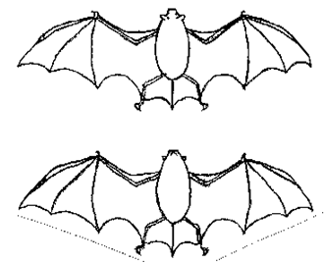  Dorsal  Ventral
Description of injuries:

Foreign substance on fur |  | Yes / No
Signs of poisoning |  | Yes / No
Immediate needs (tick all that apply) |  |  | Fluids and rest
Euthanasia |  |  | Feeding up
Veterinary care |  |  | Antibiotics
Nursing care |  |  | Release
Feeding
Was food and/or water provided by finder |  |  | If yes, what and how much:
Was food / drink offered on arrival? |  |  | If Yes, provide details:
When fed, how did it feed? |  | Well / Poorly / didn’t | Additional notes on feeding:
Urine  Details if not normal |  | Normal / Not seen | Droppings  Details if not normal |  | Normal / Not seen
Flight if no injuries are seen, was the bat given a chance to fly? |  |  |  | Yes / No
It did not try |  |  | Flew across room /area
Fell to ground |  |  | Sustained flight well
Fluttered to ground |  |  | Other
Outcome |  |  | Release date/time
Euthanasia performed? |  |  | Reason and by whom

